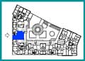
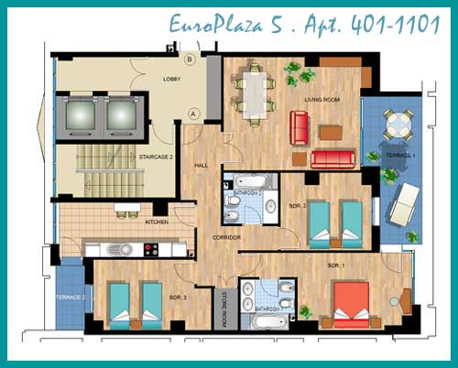

EuroPlaza 5. Apartment 401-1101
REFERENCE | INTERIOR SURFACES  in sqm
Living Room | 27
Kitchen | 12
Bedroom 1 | 17
Bedroom 2 | 12
Bedroom 3 | 13
Bathroom 1 | 5
Bathroom 2 | 5
Storeroom | 2
Hall & Corridor | 12
Internal Gross Area | 108
Terrace 1 | 13
Terrace 2 | 3
These sizes are approximate.
Layout for Apartments:
401  501  601  701 | 801  901  1001  1101

